
Digital Project
Aryos Muhsin
Matthew Cook
Group 17
Digital Analyzer



Abstract
How can you construct a digiScope, digital analyzer?
That was the question we asked ourselves when we wanted to start this project.
We based the project on analog electronics and used the mega32 chip as a processor.
In this rapport we will explain how we constructed and used our combined knowledge of electronics to program and produce a working two-channel digiScope that will display all its information on a computer screen. The user will be able to connect two outside signals to the digiScope and use the computer as an interface. The user will also be able to sample and trigger the signal.

Table of Contents
Digital Project 1
Abstract 2
Table of Contents 3
Introduction 4
Method 4
Construction 4
Circuits 5
Software 7
Java Application 7
C program on Mega32 10
Communication 14
Time log 15
Appendix A – Pictures 17
Appendix B – C Source 19
Appendix C – Flowcharts 20
C – Checking for Trigger 20
C – Processing UART Received Data 21
References 22

Introduction
How can one construct a simple but reliable and portable digital analyzer?
By using the mega32 processor chip and several other simple but key components one can do just that. Connect the signal you want to measure to a board where the mega32 chip is installed and does all the computations, such as sampling and trigging. Then display any given signal through a desired computer. The connection between the computer and the board is through a serial port (RS232).

Our digiScope has two channel inputs that allow you to measure any digital signals.
The mega32 processor is simple enough and has enough memory so that the user can use the board to sample signals and trigger them.

The sample rate will be max 128 bits, and the trigger fallows that. It is enough to get accurate information of most signals.

Method

Construction

The general principle for the construction was to make it as easy and simple as possible but still be able to deliver design specifications. When it comes to any construction of any sort complications develop when the design of the circuit is too complicated.

The ATmega32 microprocessor was the central brain of this project. Its capacity for being a fast processor and its memory storage made it the ideal hardware component.
The communication between the microprocessor and a computer was made through a serial connection (RS232), for complete circuit diagram go to appendix A.

This project uses digital signals. By using several OP- amplifiers the control of signals was maintained. The usage of amplifiers is a must because the microprocessor is built op of transistors, and those transistors use Transistor-transistor logic (TTL) to communicate logic-gating functions.
Digital signals are defined as high and low signals, or 1 and 0, they were controlled through simple electronics. The OP-amplifiers invert the incoming signals (Vin) between plus or minus 3,5V to 5V and plus or minus 7V to 10V. The outgoing signal is ether –V or +V, were –V is defined as high or 1 and +V is low or 0.
TTL has limitations of signal strength. They are between +-5. Thusly the second signal has, +-7 to 10, to be divided in half. That is easily accomplished by using
Rf = 10kΩ and R=20kΩ, observe figure 1.
The third TTL signal needs no tampering. That signal goes strait into the microprocessor. It is defined as 0V to 5V. Were 0 is low or 0 and 5V is high or 1.

Circuits

Op-Amp
Figure 1) OP-amplifier

Overall Circuit

Software
Analysis of the digital signals received by our design is accomplished primarily in software on the MEGA32 Microcontroller. The signals are then displayed through an application of a computer. Our project thus encompasses two software programs: an embedded C program for signal capture and processing, and a Java application for the user interface.

Our final design will analyze high data-rate digital signals, these signals and the Mega32’s response to them will occur much faster then we could monitor manually. Therefore, it was necessary to create the user interface (Java Application on a PC) first, for use in debugging and testing the embedded C.

Java Application
The general architecture model we chose to follow is shown below:
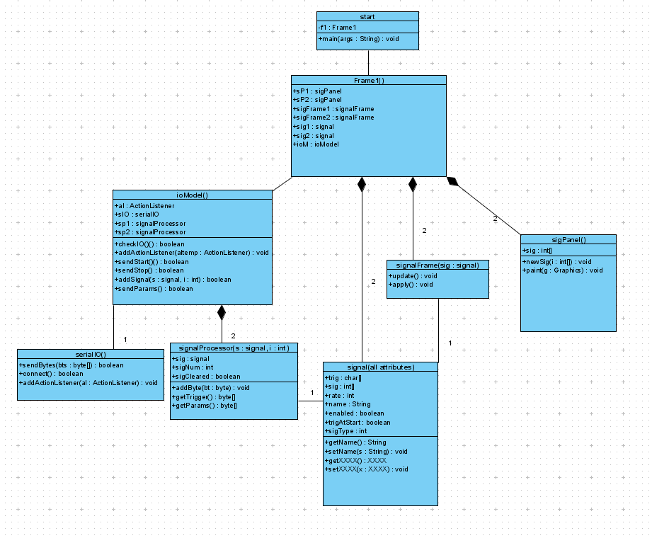

In our application, the signal class holds all information relevant to a digital signal monitored by our design. For our project, 2 signals are monitored. Frame1, the major class in our application, creates two signal objects, which are passed to their own corresponding signalFrames and signalProcessors.
The main frame displays waveforms corresponding to each signal, and has buttons brining up signalFrames to set aspects of each signal.

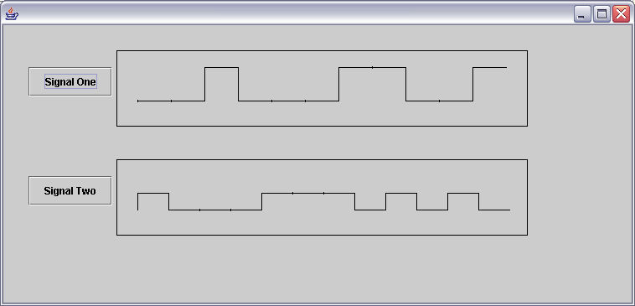

The signalFrame allows the user to specify the following aspects of the signal:

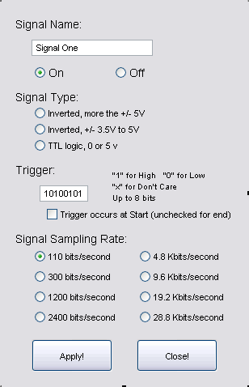

Name of the signals: displayed on the button next to the waveform captured from that signal.
State of the signal: If “On,” then the signal will be monitored for the trigger, and a sample captured. If “Off,” a new sample of the signal will not be captured.
Signal type: For double ended signals (+/- V), one of the top two options should be chosen, corresponding to the value of V. For TTL or logical signals (0 to 5), the bottom option should be selected.
Trigger Pattern: 1 for high, 0 for low, X for “don’t care.” Up to 8 bits may be used for the trigger pattern. If fewer then 8 are entered, Xs are added to the end of the trigger. The leftmost value in the text field is the first value looked for.
Location of the trigger: Enabling this captures a sample after the trigger, otherwise, a sample is captures immediately before the trigger’s occurrence.
Sample rate: This is the rate an incoming signal is sampled at, and should correspond the data rate of that signal.

These two frames make up the User Interface for our project.
Once a user has specified aspects of the signal, they must be communicated to the Mega32. This is accomplished via. an RS-232 serial connection. All data transferred over the serial connection is 8 data bits to 1 stop bit, with no Parity bits This connection is created, maintained and controlled by the ioModel class. This class also maintains 2 signalProcessor objects, one for each of the signals being monitored.

The signalProcessor also serves to create array for the waveform that will be displayed. Data is received by the application from the Mega32 in 4 bit pieces (nibbles), and these must be built up. The signalProcessor class receives a byte from the ioModel class and processes it. If a new captured signal is being sent, the signalProcessor clears the old one. If the wrong byte has been sent (i.e. it was for the other signal object), then it is ignored. Otherwise, using bit-wise operations, the nibble is added to the waveform.

Finally, the serialIO class creates the connection with the Mega32, and sends/receives data. ActionEvents from these classes notify the main frame (Frame1) when it should update the waveforms. A timer in ioModel checks for a timeout when waiting for a trigger, and sends the “Stop” command if necessary.

C program on Mega32
The C program on the Mega32 collects and analyzes samples through different pins on PORTA. The 16-bit timer, TIMER1, is used to control sample locations. Communication with the Java application is through the USART. The c program running on the Mega32 can be thought of as two independent loops: Edge Detection, and Signal Processing.

The first loop (Edge Detection) exists in a FOR loop in the main function class. Its primary function is to monitor the incoming signals for edges. This helps to ensure that samples are taken during valid parts of the incoming signal. The structure of this loop is:

YES
O

YES
O

NO
O

Idle
Does current value = last value
Re-Set sampling interrupt to ½ step from now. If this is the first “lock,” start sampling.
Is this sampling channel active?
NO
O

The loop is cycled through on each iteration of the FOR loop. One instance of this cycle is present for each channel being monitored.

The second loop is primarily interrupt driven. Three different interrupts are used in our design. the SIG_UART_RECIEVED vector activates an interrupt when new data is sent from the Java application. The two output compare interrupts: SIG_OUTPUT_COMPARE1A and SIG_OUTPUT_COMPARE1B are used to control the sample locations (A is used for channel 1, B for 2).

From an idle state, if data is received over the USART, the interrupt is triggered, and the data is processed according to its type. If one of the output compare interrupts is triggered. A sample is taken and stored. The last 8 samples taken are compared to the trigger, and actions are taken accordingly. See the FLOWCHARTS in Appendix C for details.

Two different time steps can be written in the output compare register. If an edge is detected, the value is set to: (current time) + (1/2 a time step). This places the next sample in approximately the middle of the next symbol. When the interrupt is triggered, the current time is in the middle of a symbol, so the next symbol’s center is a full time step away, and the value of the output compare register is set to: (current time) + (1 time step). Since an edges occur in between ideal samples, when a sample time is set by a edge, it will overwrite an existing sample location set by an interrupt. This serves as a very rudimentary “bit-sync” and helps avoid sampling at invalid locations (at transitions, etc.)

Edge, set sample time to ½ step from here (red arrows).

INTERRUPT, set sample time to a full step from here (blue arrows)

Since the timer counts CPU cycles, he time step used is (rate/cpu_rate) + some “slack” time. Slack time is added so that after a long series of successive 1s or 0s, an edge is more likely to occur before an extra sample is taken.

The last 8 bits are compared to the trigger by the following process:

[Last 8 bits] & [Trigger Mask] – [Trigger Values]

this statement is 0 if the trigger has been found. The Trigger Mask sets “don’t care” bits to 0, as they are in the Trigger Values byte. Subtracting [Trigger values] compares the two. Trigger data is stored in the following format:

[Trigger Mask] = a bit is 0 if it is an “X” – don’t care, otherwise 1
[Trigger Values] = a bit is 1 if “1”, 0 if “0” and 0 if “X”.

If the trigger is found and is set to mark the start of a sample, sampling continues until the next storage address is the location of the trigger (255 more bits), then the whole sample is sent. Otherwise, the trigger marks the end of the needed sample, and the whole sample is sent.

Samples are stored in a 256 element array of unsigned chars. Each char(x) is 1 bit contains the 7 least significant bits of the previous char, along with the current sample (in the least significant bit location:
X-1 | 1110 0111
X | 1100 111X
X+1 | 1001 11XY
X+2 | 0011 1XYZ

This system, while being inefficient with space, allows quick comparison and storage of a set of samples.:
When a new sample is taken:
1. Shift last 8 samples left once
1111 0000 >> 1110 0000
2. OR last 8 samples with 1 or 0, according to
1110 0000
+ 0000 000X

- Compare to the trigger
- Store

Additionally, this allows easy access to data in 4 bit sets for sending to the Java application. 256 values are used to avoid extra commands to reset the next storage location to 0 after using location 255:

X is an unsigned char, the location of the next storage location
X = 255;
After storage, X = X + 1 = 256, but because X is only 8 bits, X = 0;

Parameters concerning the signal (Masks, values, etc) are stored in a 4 element array:
[0,0, (3 bits for rate), (trigger location, 1 for Start), (enabled), (channel #)]
[Signal Mask] – 1 in location of Pin being sampled
[Trigger Values]
[Trigger Mask]

Sampling rates : 000 – 150 bits/sec
001 – 300 bits/sec
010 – 1200 bits/sec
011 – 2400 bits/sec
100 – 4800 bits/sec
101 – 9600 bits/sec
110 – 12.9 kbits/sec
111 – Not Used

Communication
Java to Mega32
Signal Parameter: 4 bytes, always in order, never interrupted.
[0,0,R,R R,T,E,N] 0,0 indicates type of data
R,R,R is the rate
T is 1 if the trigger is at Start
E is 1 if enabled
N is 1 for channel 2, 0 for 1
[Signal Mask] 1 in location of pin to sample
[Trigger Values] 1 = “1”, 0 = “0”, 0 = “X”
[Trigger Mask] 0 for “don’t care” bits, else 1

Start: 1 byte
[1,1,1,1 1,0,1,0] 0xFA the two leading 1s differentiate this from the first byte of a set of parameters

Stop: 1 byte
[1,1,1,1 0,1,0,1] 0xF5;

Mega32 to Java
Basic format: [C,C,N,A D,D,D,D] C,C are the command bits:
0,0 = sample data
0,1 = no channels enabled
1,0 = Channel 1 finished
1,1 = Channel 2 finished
N is the Signal Number
A is 1 to append data, 0 to replace

If Returning the 1st nibble of data:
[0,0,0,0 D,D,D,D] Channel 1
[0,0,1,0 D,D,D,D] Channel 2

If Returning 2nd or higher nibble of data
[0,0,0,1 D,D,D,D] Channel 1
[0,0,1,1 D,D,D,D] Channel 2

If given START command, but no channels enabled, returns:
[0,1,1,1 1,1,1,1] 0x7F

If Finished sending data:
[1,0,1,1 1,1,1,1] Channel 1 0xBF
[1,1,1,1 1,1,1,1] Channel 2 0xFF

Time log
25/1
(13.15 – 15.15)
Selected Digiscope as project chose platform
Got Approval
Preliminary drawings of display, Schedule, Project Block Diagram

Decided to sample only 2 signals and to use the Max 32 chip, for increased memory. Display on computer through Java.

Planned meeting for next week, assigned “homework” of studying TTL vs. Serial, I/O circuits.

31/1
(13.15 – 17.00)
Designed circuits, gained preliminary approval. Choose to use MAX 232 for translating from TTL to Serial. Selected appropriate pins for signals / power. Created more sophisticated schematic of layout, including preliminary values for circuit elements.

Discussed program design: Where to analyze data (chip), How to store data (1 bit per byte or accumulation of bytes). More planning of software design.

Checked out box and Mega 32 for project. Got equipment and introduction to its use. Some Caps, Resistors, Drivers, etc.

5/2
Own work – started work on java side of project. Able to create drawing corresponding to signals.

7/2
(15.00 – 17.00)
Started soldering and construction of prototype. Selected OpAmps and other components, made list of additional equipment needs.

8/2
(15.00 – 17.00)
Got the additional equipment needed. Create OpAmp circuit on test board, check performance. Attached chip-holders for Amps, Buffers, etc.

15/2
(13.20 – 16.00)
Created Amp Circuits on board. Wired and soldered. Tested Amp/diode/buffer circuit. Noticed odd behavior, needs further analysis.

16/2
Testing, fine tuning, adding button. More work on programming Atmega32 and serial.

17/2
Testing, adding refresh button and trying to finish the JAVA and C++ codes.

18/2
More testing, updating circuit diagram and starting on report.

19/2
More changes done on circuit, taking pictures of complete board.
More work on report and programming

20/2 – 27/2
Finish Programming, Testing and Report

Appendix A – Pictures

Prototype Circuit for Serial Communictaion

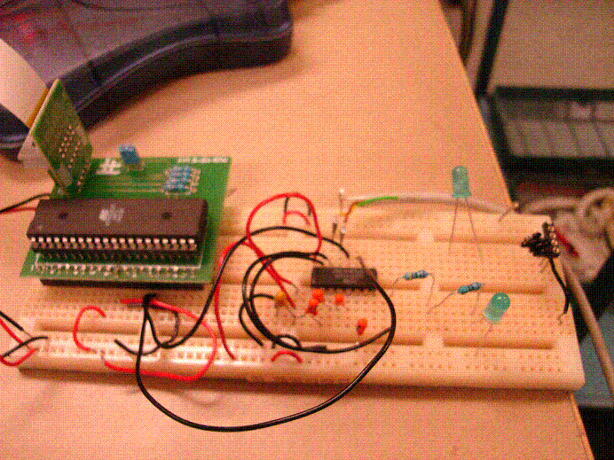

Final Design From Top:

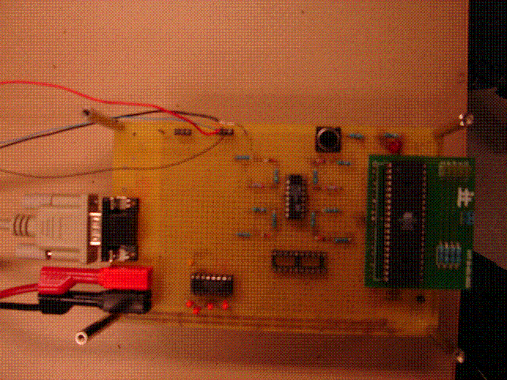

Final Design From Below:

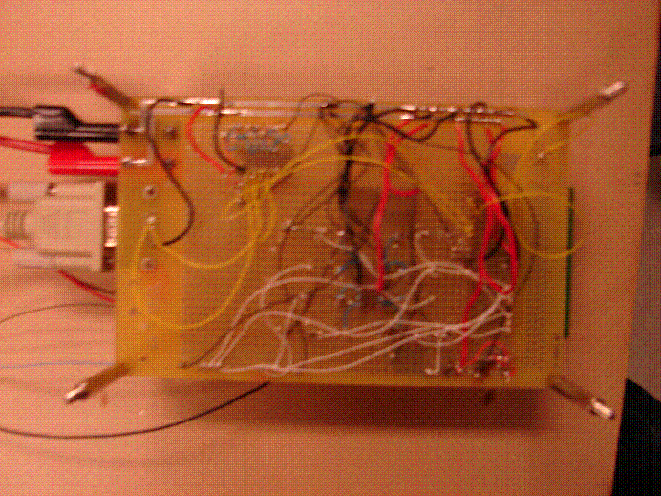

Appendix B – C Source Code

Mega32_2.c

#include <avr/io.h>
#include <avr/interrupt.h>
#include <avr/signal.h>

#include "get_ratesANDtimes.h"
#include "sigAnalysis.h"
#include "mega32_2.h"

//-----These arrays hold information spcific to signals
unsigned char sigSamples[2][256];//holds samples when taken
unsigned char nextSampleLoc[2];//location to store next sample collected
unsigned char trigSampleLoc[2];//holds the location of the sample holding the trigger;
unsigned char trigFound[2];

unsigned char sigByteParams[2][4];//holds data about signals [params][sigMask][tVals][tMask]
unsigned char sigEnabled[2];// sE[] is > 0 if a signal is enabled
unsigned char trigStart[2];// tS[] is > 0 if a signals trigger should occur at a start
unsigned int sigRate[2];// sR[] holds samples rates
unsigned int sigStep[2];

//-----These varialbes are used for getting and maintaing a sync with the incomming signal
unsigned char lastONE;
unsigned char currONE;
unsigned char lockONE;
unsigned char runONE;

unsigned char lastTWO;
unsigned char currTWO;
unsigned char lockTWO;
unsigned char runTWO;

//------These are used to control the processing of incomming signals
unsigned char pAS; //corresponds to the state of the FSM for acquiring parameters
unsigned char pAN; // 1 or 0 for the signal being acquiried
unsigned char acqParams; // 1 if currently acquiring parameters, 0
unsigned char tempRcvd;

int main(void){
unsigned char dummy;
//set up for 8 data,2 stop

UBRRL = BAUD_PRESCALE; // Load lower 8-bits of the baud rate value into the low byte of the UBRR register
UBRRH = (BAUD_PRESCALE >> 8); // Load upper 8-bits of the baud rate value into the high byte of the UBRR register
UCSRB |= (1<<RXCIE)|(1 << RXEN) | (1 << TXEN); // Turn on the transmission and reception circuitry
UCSRC |= (1 << USBS)|(1 << URSEL) | (1 << UCSZ0) | (1 << UCSZ1); // Use 8-bit character sizes

TCCR1B |= (1<<CS10);//enable counter 1

sei();

while ( UCSRA & (1<<RXC) ) dummy = UDR;//flush input buffer
initializeParams();

//test
//populateTestArray(); //uncomment if using getTestInput()

for (;;) // Loop forever
{
if (runONE){
lastONE = currONE;
currONE = (PINA & sigByteParams[0][1]); // mask the signal we need
if (lastONE != currONE){ //an edge has occured, re-sync the counter
syncONE();
if (!lockONE){ //this is the first lock
lockONE = 1; //set locked
startSampling(0);
}
}
}
if (runTWO){
lastTWO = currTWO;
currTWO = (PINA & sigByteParams[1][1]);// mask the signal we need
if (lastTWO != currTWO){ //an edge has occured, re-sync the counter
syncTWO();
if (!lockTWO){ //this is the first lock
lockTWO = 1; //set locked
startSampling(1);
}
}
}
}

return 0;
}

void startItUp (){// run to start signal watching
if (!(sigEnabled[0] | sigEnabled[1])){//no signals enabled, don't start
send_byte(0x7F); //This works
return;
}
else{
if (sigEnabled[0]) runONE = 1;
if (sigEnabled[1]) runTWO = 1;
lockONE = 0;
lockTWO = 0;
}
}

SIGNAL (SIG_UART_RECV){
;
if (acqParams){//if currently acquiring parameters,
unsigned char temp = UDR;
sigByteParams[pAN][pAS] = temp;
if(pAS >= 3){ //if that was the last paramter bit
setSigSettings(sigByteParams[pAN][0], pAN);
acqParams = 0;
pAS = 0;
}
else pAS = pAS + 1;
}
else{
unsigned char temp = UDR;
if (!(temp & 192)){ //if this is the first byte of a paramter set
pAN = (temp & 1);// pAN is now the signal number
sigByteParams[pAN][0] = temp;
pAS = 1;
acqParams = 1;
}
else{// this is not a paramter byte
if ((temp & 5)){
stopSampling(0);
stopSampling(1);
}
else {
startItUp();
}
}
}
}

ISR(SIG_OUTPUT_COMPARE1A){ //interrupt to signal the time for sig1's sampling
unsigned char sreg;
unsigned int currTime;
//reset the interrupt
sreg = SREG; //save flags
cli(); //disable interrupts
currTime = TCNT1; //get current time
OCR1A = currTime + sigStep[0]; //add a step until next sample, write time to compare RegA
TIMSK |= ( 1<<OCIE1A); //set interrupt
SREG = sreg; //replace flags
sei(); //enable interrupts

collectSample(0); //collect a sample
}

ISR (SIG_OUTPUT_COMPARE1B){ //interrupt to signal the time for sig2's sampling
unsigned char sreg;
unsigned int currTime;
//reset the interrupt
sreg = SREG; //save flags
cli(); //disable interrupts
currTime = TCNT1; //get current time
OCR1B = currTime + sigStep[1]; //add a step until next sample, write time to compare RegA
TIMSK |= ( 1<<OCIE1B); //set interrupt
SREG = sreg; //replace flags
sei(); //enable interrupts

collectSample(1); //collect a sample
}

void collectSample(unsigned char n){//called by compare interrupt, collects a sample, looks for tirgger, etc.
unsigned char samp, last, next;
if (PINA & sigByteParams[n][1]) samp = 1; //if the masked value of the port is 1, the sample is 1
// if (getTestInput(n) &sigByteParams[n][1]) samp = 1; //used for testing only

else samp = 0;

next = nextSampleLoc[n];
last = next - 1;

sigSamples[n][next] = ((sigSamples[n][last] << 1) | samp); //take the previous value, shift right, append samp
if (!trigFound[n]){ //if the trigger has not already been found
if (trigCheck(sigSamples[n][next], sigByteParams[n][2], sigByteParams[n][3])){//true if trigger was just recieved
if (trigStart[n]){ //if the trigger occurs at the start of the sample
trigFound[n] = 1; //set trigFound to true
trigSampleLoc[n] = next; //mark this location, keep sampling
nextSampleLoc[n] = next + 1;
}
else{ //this (the trigger) is the end of the sample, done
trigSampleLoc[n] = next;
stopSampling(n);
send_whole_sig(n);
if(!n) send_byte(0xBF);
else send_byte(0xFF);
return;
}
}
else{ //the trigger was not just found, and still needs to be found
nextSampleLoc[n] = next + 1;
return;
}
}
else{ //if the trigger was already found
nextSampleLoc[n] = next + 1;
if (nextSampleLoc[n] == trigSampleLoc[n]){//this is the last value before the trigger, stop,send
stopSampling(n);
send_whole_sig(n);
if(!n) send_byte(0xBF);
else send_byte(0xFF);
return;
}
else return; //keep sampling
}
return;
}

void setSigSettings(unsigned char byt, unsigned char sN){//extract signal settings from the 1'st byte recieved
sigEnabled[sN] = (byt & 2);
trigStart[sN] = (byt & 4);
sigRate[sN] = getRate(byt);
sigStep[sN] = getTimeStep(byt);
}

void stopSampling(unsigned char chan){ //stop sampling channel chan call after trigger found
if(chan){
runTWO = 0; //stop looking for edges
TIMSK &= (0xf7); //turn off interrupt flag OCIE1B
}
else{
runONE = 0;
TIMSK &= (0xef);
}
}

void startSampling(unsigned char chan){//clears markers used for sample collecting
nextSampleLoc[chan] = 0;
trigFound[chan] = 0;
trigSampleLoc[chan] = 0;
}

void send_byte(unsigned char byt){
while(!(UCSRA & (1<<UDRE)) )
;
UDR = byt;
}

void send_whole_sig(unsigned char chan){
unsigned char cLoc, tLoc, curr; //current location, trigger's location, current byte
unsigned char mSNf, mSNo; //most significant nibbles for teh first byte being sent, and all others
unsigned char i;
tLoc = trigSampleLoc[chan];

mSNf = (chan << 5); // so, chan = 0000 000N, mSNf = 00N0 0000
mSNo = (mSNf | 16); // mSNo = 00N1 0000

if (trigStart[chan]){ //if this signal's trigger occurs at the start
curr = sigSamples[chan][tLoc];
send_byte(mSNf | (curr >> 4)); //so. curr = trig gerx, sending (00N0 trig)

for(i = 1;i < 64; i++){
cLoc = tLoc + 4*i;
curr = sigSamples[chan][cLoc];
send_byte(mSNo | (curr >> 4));
}
}
else{ //trigger occurs at end
curr = sigSamples[chan][tLoc + 4];
send_byte(mSNf | ( 0x0f & curr)); //so. curr = trig gerx, 0x0f&curr = 0000 gerx sending (00N0 gerx)

for (i = 2; i < 65 ; i++){
cLoc = tLoc + 4*i;
curr = sigSamples[chan][cLoc];
send_byte(mSNo | (0x0f & curr));
}
}
}

void syncONE(){ //call when an edge has been found
unsigned char sreg;
unsigned int tCurr, nextSample;
sreg = SREG; //save flags
cli(); //disable interrupts
tCurr = TCNT1; //get current time
nextSample = TCNT1 + sigStep[0]/2; //add a half step until next sample
OCR1A = nextSample; //write time to compare reg A
TIMSK = TIMSK |(1<<OCIE1A); //set interrupt
lockONE = 1; //set lockONE to true
SREG = sreg; //replace flags
sei(); //enable interrupts
}

void syncTWO(){ //see comments above
unsigned char sreg;
unsigned int tCurr, nextSample;
sreg = SREG;
cli();
tCurr = TCNT1;
nextSample = TCNT1 + sigStep[1]/2;
OCR1B = nextSample;
TIMSK = TIMSK|( 1<<OCIE1B);
lockTWO = 1;
SREG = sreg;
sei();
}

void initializeParams(){ //puts default values in paramters
sigByteParams[0][0] = 1; //rate 150, not enabled, trigger at end = 1, trigger at start = 5
sigByteParams[1][0] = 1;
sigByteParams[0][1] = 1; //Default to signal mask for high
sigByteParams[1][1] = 16;
sigByteParams[0][2] = 0x55; //Default trigger values to 1010 0101
sigByteParams[1][2] = 0x55;
sigByteParams[0][3] = 0xFF; //Default Trigger mask to all bits count
sigByteParams[1][3] = 0xFF;
setSigSettings(sigByteParams[0][0], 0);//file data into settings
setSigSettings(sigByteParams[1][0], 1);
}

sigAnalysis.c

#include "sigAnalysis.h"

unsigned int test[16];
unsigned char i,j,k,l;

unsigned char trigCheck(unsigned char samp, unsigned char tVals, unsigned char tMask){
samp = (samp & tMask);//mask off don't care bits
samp = (samp - tVals);// compare to the triggers value;

if (samp) return 0; //samp is 0 if it's the trigger, else it's not
else return 1;
}

void populateTestArray(){
i = 0;
j = 0;
test[0] = 0x0000;
test[1] = 0x1111;
test[2] = 0x2222;
test[3] = 0x3333;
test[4] = 0x4444;
test[5] = 0x6666;
test[6] = 0x7777;
test[7] = 0x8888;
test[8] = 0x9999;
test[9] = 0xbbbb;
test[10] = 0xcccc;
test[11] = 0xdddd;
test[12] = 0xeeee;
test[13] = 0xffff;
test[14] = 0x0000;
test[15] = 0x55ff; // for trig at end, will pring 0000, 1111... to 55,
//for trig at start, will print 55ff 0000 1111.....
}

unsigned char getTestInput(unsigned char chan){ //This can be called to get values from the table above
if (chan) return getTestInput2(); //for debugging purposes
else return getTestInput1();
}

unsigned char getTestInput1(){//for testing, returns a value from the table
unsigned char x;
x = (test[i] >> (15-j));
x = x & 1;

j = j + 1;
if (j == 16){
j = 0;
i = i + 1;
}
if (i == 16) i = 0;

if (x) return 0xFF;
else return 0x00;
}

unsigned char getTestInput2(){//for testing, returns a value from the table
unsigned char x;
x = (test[l] >> (15-k));
x = x & 1;

k = k + 1;
if (k == 16){
k = 0;
l = l + 1;
}
if (l == 16) l = 0;

if (x) return 0xFF;
else return 0x00;
}

get_ratesANDtimes.c

#include "get_ratesANDtimes.h"

unsigned int getRate(char c){
c = (c >> 3);
if (c == 0) return 150;
else if (c == 1) return 300;
else if (c == 2) return 1200;
else if (c == 3) return 2400;
else if (c == 4) return 4800;
else if (c == 5) return 9600;
else if (c == 6) return 12900;
else return 28800;
}

unsigned long getTimeStep(char c){
unsigned long i = (unsigned long)getRate(c);

return (unsigned long)(CPU_RATE/i) + SLACK;
}

Appendix C – Flowcharts

C – Checking for Trigger
Have 255 more samples been taken?
No
Sample until 255 more the trigger

No
Yes
No
Yes (Trig at Start)
New Sample Taken
Append to last 7 samples

Send to JAVA App.

Has the trigger been found?
Yes
Is This the Trigger?
Yes
Trigger At Start
No
Keep looking for Trigger

C – Processing UART Received Data

Parameter Byte
Parameter Byte
Parameter Byte
Parameter Byte
Start Command
IDLE

Stop Sampling
Start Sampling
Receive first Parameter
Receive 2nd Parameter (Sig. Mask)
Receive 3rd Parameter (Trig. Values)
Receive 4th Parameter (Trig. Mask)
Extract Settings from 1st byte
UART DATA RCVD
Parameter Byte
Stop Command

References

AVR MEGA32
Digitala Projekt Manual – Atmega32
Lund Intituted of Technology
Department of Information Technology
http://www.it.lth.se/digp/utrust.asp

MAX232 – Serial Port Driver
http://www.it.lth.se/digp/datablad/datablad_index.asp

ca3160 – Op Amps
http://www.it.lth.se/datablad/Analog/opamp/ca3160.pdf

